**MongoDB Create & Insert Database**

In MongoDB, the first basic step is to have a database and collection in place. The database is used to store all of the collections, and the collection in turn is used to store all of the documents. The documents in turn will contain the relevant Field Name and Field values.

The snapshot below shows a basic example of how a document would look like.

[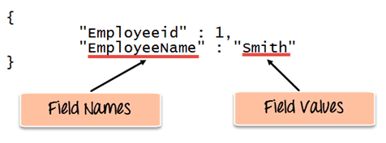](https://cdn.guru99.com/images/MongoDB/112115_0607_Introductio1.png)

The Field Names of the document are "Employeeid" and "EmployeeName" and the Field values are "1" and "Smith' respectively. A bunch of documents would then make up a collection in MongoDB.

In this article, you will learn -

* [Creating a database](https://www.guru99.com/create-read-update-operations-mongodb.html#1)
* [Creating a collection](https://www.guru99.com/create-read-update-operations-mongodb.html#2)

**Creating a database using “use” command**

Creating a database in MongoDB is as simple as issuing the "**using**" command. The following example shows how this can be done.

[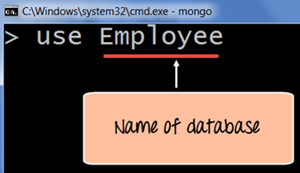](https://cdn.guru99.com/images/MongoDB/112115_0607_Introductio2.png)

**Code Explanation:**

1. The **"use"** command is used to create a database in MongoDB. If the database does not exist a new one will be created.

If the command is executed successfully, the following Output will be shown:

**Output:**

[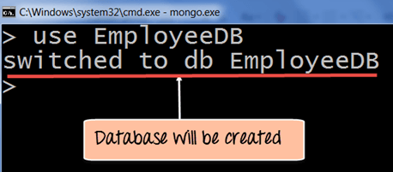](https://cdn.guru99.com/images/MongoDB/112115_0607_Introductio3.png)

MongoDB will automatically switch to the database once created.

**Creating a collection using insert()**

The easiest way to create a collection is to insert a record (which is nothing but a document consisting of Field names and Values) into a collection. If the collection does not exist a new one will be created.

The following example shows how this can be done.

db.Employee.insert

(

{

"Employeeid" : 1,

"EmployeeName" : "Martin"

}

)

**Code Explanation:**

As seen above, by using the **"insert"** command the collection will be created.

**Adding documents using insert() command**

MongoDB provides the **insert () command** to insert documents into a collection. The following example shows how this can be done.

**Step 1)** Write the "insert" command

**Step 2)** Within the "insert" command, add the required Field Name and Field Value for the document which needs to be created.

[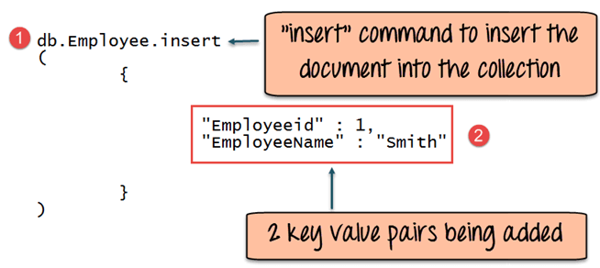](https://cdn.guru99.com/images/MongoDB/112115_0607_Introductio5.png)

**Code Explanation:**

1. The first part of the command is the "**insert statement"** which is the statement used to insert a document into the collection.
2. The second part of the statement is to add the Field name and the Field value, in other words, what is the document in the collection going to contain.

If the command is executed successfully, the following Output will be shown

**Output:**

[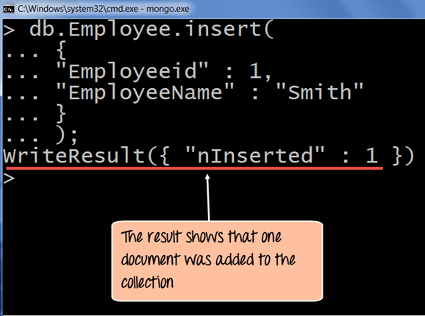](https://cdn.guru99.com/images/MongoDB/112115_0607_Introductio6.png)

The output shows that the operation performed was an insert operation and that one record was inserted into the collection.